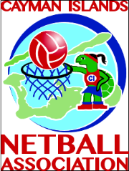

REGISTRATION AND MEMBERSHIP FORM FOR THE
2016 MIXED LEAGUE
Email form to caymannetball@candw.ky

Mixed League

Mixed league netball was originally introduced to encourage all sectors in the Cayman business community to participate in leisure Netball and to bring new persons into the netball fraternity. The established clubs are invited to participate but must have new persons who come from this sector and are not attached to clubs. Whilst there must be some competitiveness, the concept is for recreational leisure and enjoyment.

Name of Company Netball ________________________________

Uniform
colours:

Contact person: _______________________________________________

ADDRESS:

EMAIL: _______________________________________________

TELEPHONE: ___________________

FAX: _______________________________________________

Position | Name | Email
Coach
Team Manager
Team Medic

Club non- playing volunteers to assist as table officials

Name | Contact Number | Email
PLAYER REGISTRATION

 | NAME | AGE | D.O.B | P.O. BOX | CELL | EMAIL
1
2
3
4
5
6
7
8
9
10
11
12
13
14
15
16
17
18
19

SIGNATURE: _______________ POSITION: ______________

DATE: _______________

NB it is important complete all contact information on players
Registration fees must be attached to completed form

